**W2-S2** PRACTICE

*HTML ELEMENTS*

## *At the end of this practice, you should be able to…*

* Manipulate **Image**, **Tables, Lists, paragraphs, headings and hyperlinks**

## *How to work?*

* Download **the start code** from the LMS
* Open the folder in VS Code

## *How to submit?*

* **Create a repository on GitHub** with the name of this practice:

Ex: C2-S1-PRACTICE

* **Push your final code** on this GitHub repository (if you are lost, [follow this tutorial](https://www.datacamp.com/tutorial/git-push-pull))
* Finally, submit on **Google classroom** your GitHub repository URL

Ex: https://github.com/thebest/ C2-S1-PRACTICE.git

## *Are you lost?*

*You can read the following documentation to be ready for this practice:*

* [WC3 School - Links](https://www.w3schools.com/html/html_links.asp)
* [WC3 School -Tables](https://www.w3schools.com/html/html_tables.asp)
* [WC3 School – Bloc and inline elements](https://www.w3schools.com/html/html_blocks.asp)
* [WC3 School -Tables](https://www.w3schools.com/html/html_images.asp)

 *No AI during this work!*

* No AI during this practice so you can **learn to solve problems by searching on internet**.

# EXERCISE 1 - A Blog Post

For this exercise, your need to create a simple blog post with the following structure:

* A <h1> for the title of the blog post (*e.g., "My First Blog Post")*
* Two paragraphs of text using the <p> tag, discussing any topic of your choice
* A hyperlink to an external website (*e.g., link to a Wikipedia article related to your blog topic*)
* A <h2> tag for a subheading (*e.g., "Conclusion")*
* A final paragraph summarizing your blog post.
  + You should also create a hyperlink to a mail (*e.g., "any question, please contact me")*

You can find bellow an example of post (*just an example):*

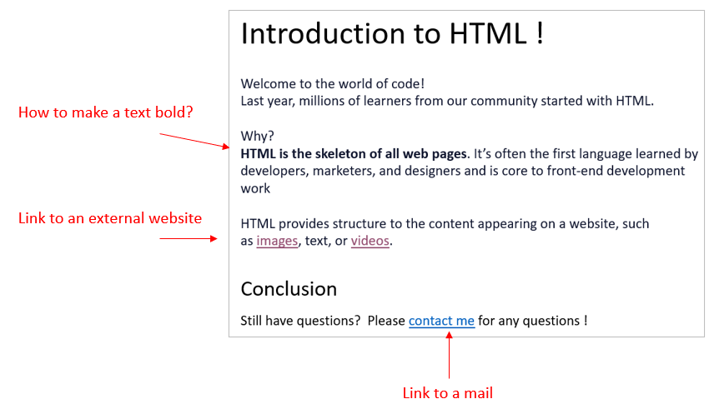

# EXERCISE 2 – Relative paths

Here is a website folder structure.

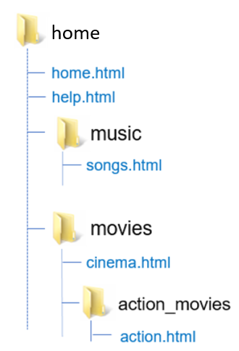

**YOU JOB:** Fill the table with the **missing hyperlinks**, so that we **can create a link** from the source page to the destination page.

|  |  |  |
| --- | --- | --- |
| ***SOURCE PAGE*** | ***DESTINATION PAGE*** | ***HYPERLINK*** |
| action.html | cinema.html | <a href="../cinema.html"> |
| home.html | songs.html | <a href=”./music/songs.html”> |
| help.html | action.html | <a href=”./movies/action_movies/action.html”> |
| cinema.html | help.html | <a href=”../help.html”> |
| action.html | home.html | <a href=”../../home.html”> |
| cinema.html | action.html | <a href=”./action_movies/action.html”> |
| songs.html | action.html | <a href=”../movies/action_movies/action.html”> |
| action.html | songs.html | <a href=”../../music/song.html”> |

# EXERCISE 3 – A Small Website

For this exercise, you need to build a small website with 4 pages and a **menu**

* Home
* About us
* Our Services
* Contact

We should be able to navigate **from any page to the other pages**, using the menu

Each page of your website should contain:

* The menu
* A title
* An image
* A list of items
* A paragraph



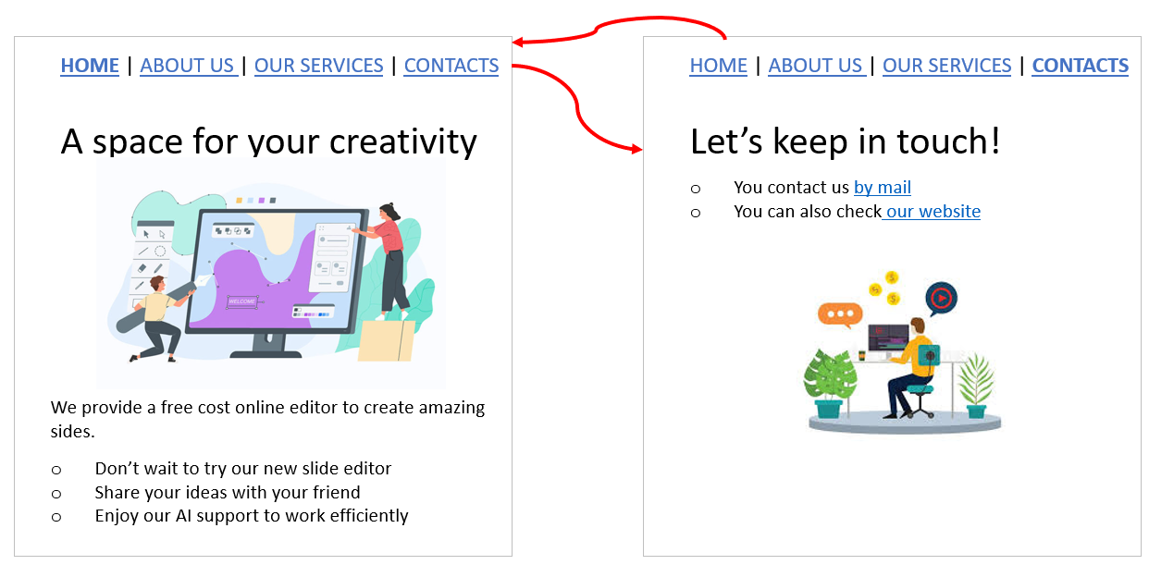

F*eel free to express your creativity!*

# EXERCISE 4 – Product Information

For this exercise, you need to create tables

* Create a table to display a product catalog for an **online store**
* Use an <h2> tag to title the table (e.g., "Product Catalog").
* Create a table with 4 columns:
  + Product Name
  + Price
  + Quantity
  + In Stock
* Add 3 rows of product data with sample values (e.g., "T-shirt," "$10," "20," "Yes").
* Add a header row at the top of the table to describe each column.

Welcome to CADT Shop!

|  |  |  |  |
| --- | --- | --- | --- |
| Product Name | Price | Quantity | In Stock |
| C# Book | $10 | 5 | YES |
| CADT Polo | $12 | 60 | YES |
| CADT mouse | $100 | 3 | NO |

## *Are you lost?*

* [WC3 School -Tables](https://www.w3schools.com/html/html_tables.asp)

## *Bonus*

* As a bonus: you **add another column**, containing a [thumbnail](https://www.techtarget.com/whatis/definition/thumbnail#:~:text=A%20thumbnail%20is%20a%20small,photographers%20typically%20use%20this%20term.) (small image) of the products!
* As a bonus: you can try to **style your table** using the <style> tag inside the <header>